EDM Council WDP

Website Enhancements Strategy

v1.0

September 27, 2023

Revision History

Date | Version | Description | Author(s)
September 27, 2023 | 1.0 | Initial version | Prosasty Chaudhuri  Vanessa Jones-Nyoni

Table of Contents:
1.0 Purpose
2.0 Scope
3.0 Enhancement Goals
4.0 Implementation Timeline & Roadmap
5.0 Roles, responsibilities and delegations
6.0 Operational Process

1.0 Purpose
The EDM Council WDP website is committed to providing valuable content, fostering engagement and creating a supportive community. This website is a critical channel of communication for the council, and its users expect to find accurate, timely, and relevant information. To meet this expectation, this document outlines the strategy for the development and maintenance of the WDP website.

2.0 Scope
Women Data Professionals (WDP) website within the EDM Council website.
Target audience for website:
- Members of WDP
- Potential members (restricted view) to landing page, team page, membership page
- Other organizations we collaborate with

3.0 Enhancement Goals
Initiate

- Home Page
- About Us Page: purpose and aims/ objectives, maybe founding story, testimonials from a few communities’ members
- Register: become a member page, why and how
- Meet the team page: (example roles) Founder, Chair, Community Director, Events Director, Partnerships Director, Comms manager, mark and social media lead, project manager, women in health
- The Chapters page (breakdown of the divisions within EDM Council WDP)
Evolve

- Partners Page: who they are and why they important to us. comms on new members and bios of women
- Partners Page: who they are and why they important to us. comms on new members and bios of women
- Nomination page: for any EDM Council nominations and previous winners’ bios/profiles
- Rising stars Page: nomination and bios
- Training page: partnership with tech vendors, free/ subsidized training for member
- Events page: calendar of events/ networking opportunities
- Contact us page:
- Frequently asked questions and glossary of Terms
**
Optimize

- Resources:
- Annual EDM Council WDP week: a week each year to bring together the Global community, networking, speaker events, townhall etc. showcase year’s work and innovation in the field of data.
- Podcast page: videos / blogs
- Dashboard/ studies/ whitepapers: library of resources e.g. metrics on diversity and inclusion across industry. STEM/ girls in data page: work in school college universities
- Data Trends:
- Updates on the latest trends and technologies e.g. data governance, data science and analytics and other related fields
- Case studies showcasing innovative data projects
- Career Development:
- Articles and guides on e.g. navigating career paths in data professions, building a strong portfolio
- Social Media Integration:
- Integration with social media platforms (e.g. LinkedIn) for sharing content and engaging with the community
- Blog:
- Blog posts (frequency TBD) covering a variety of topics:
  - Career advice for women in data professions
  - Data analysis tutorials and tips
  - Profiles of accomplished women in data roles
  - Insights into data trends and technologies
  - Include guest posts from industry experts
- Newsletter:
- Regular newsletter featuring top blog posts, upcoming events and community highlights
- Exclusive content or offers for subscribers
- Diversity and Inclusion
  - Articles and resources on promoting diversity and inclusion in data professions
  - Interviews with diversity advocates and leaders
  - Discussions on intersectionality and unique challenges faced by women from diverse backgrounds
- Other Considerations for the website:
  - Privacy Policy and Terms of Use
    - Clearly articulated privacy policy and terms of use for website visitors
  - Search Engine Optimization (SEO)
    - Regularly optimize content for relevant keywords and meta tags to improve search engine visibility
  - Analytics and feedback
    - Regularly monitor website analytics to assess content performance and user engagement
    - Collect user feedback through surveys or contact forms to make improvements

4.0 Implementation Timeline & Roadmap
# | Enhancement Goals | 2023 | 2024
1 | Home Page | Yes
2 | About Us Page | Yes
3 | Register | Yes
4 | Meet the team page | Yes * | Yes
5 | The Chapters page | Yes * | Yes
6 | Partners Page |  | Yes
7 | Nomination page |  | Yes
8 | Rising stars Page |  | Yes
9 | Annual EDM Council WDP week |  | Yes
10 | Training page |  | TBD
11 | Events page |  | Yes
12 | Podcast page |  | Yes
13 | Dashboard/ studies/ whitepapers |  | Yes
14 | STEM/ girls in data page |  | TBD
15 | Frequently asked questions and glossary of Terms |  | Yes
* 2023 will focus on Contents teams related material only
** Timeline for Optimize items is TBD

5.0 Roles, Responsibilities and Delegations
ROLE | RESPONSIBILITY
Website and Content Strategist / Manager | Pinder/Vanessa  - Develop a comprehensive website strategy aligned with WDP goals and objectives  - Define the target audience and user personas  - Set clear KPIs to measure the success of the website  - Create a timeline for the website project  - Oversee the implementation of the strategy and monitor its progress.  - Continuously analyze data and user feedback to make strategic adjustments  - Develop a content strategy that aligns with the overall website strategy  - Collaborate with designers and developers to ensure content is effectively presented on the website.  - Create prototypes and mockups to visualize the design  - Conduct usability testing and gather user feedback for design improvements
UX/UI Designer | Website Graphic Designer (Delegation)  - Design the user experience (UX) and user interface (UI) of the website based on prototypes and mockups created by the Website and Content Strategist / Manager  - Ensure the website is user-friendly and intuitive to navigate  - Collaborate with developers to implement the design elements  - Conduct usability testing and gather user feedback for design improvements
Technical Support | Website Admin (Delegation)  - Upload content to website

6.0 Operational Process
To publish changes to the website, Admin access is required. The following steps should be taken to make changes:
- Confirm Admin access by ensuring the “Edit Page” and “Edit Navigation” functions are visible / accessible
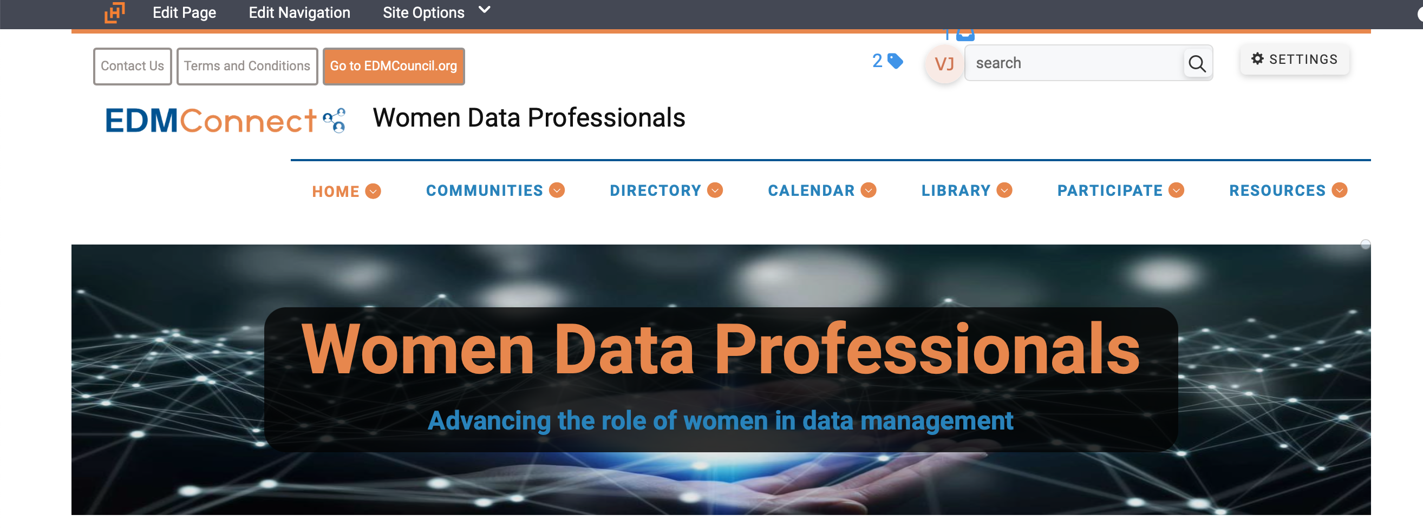
- Click on “Edit Page” (“Edit Navigation” is rarely used)

- To make minor changes to existing content, click on “Edit” in the relevant frame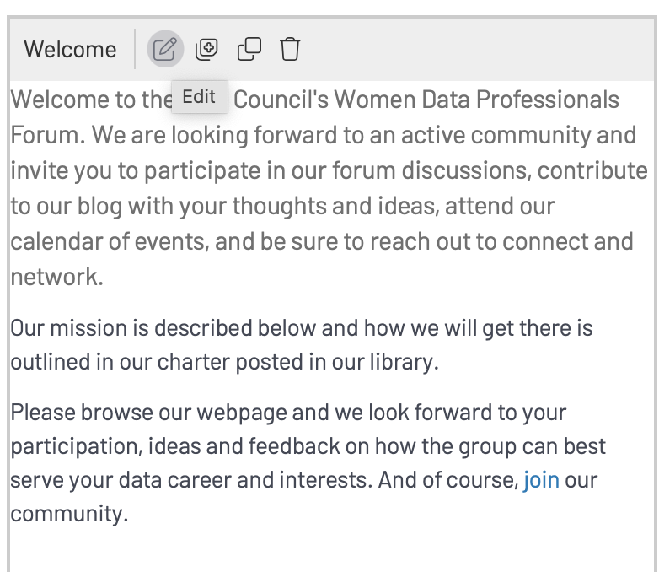

- The simplest way to go about creating new content is to duplicate existing content that is similar in nature to the new content you would like to create. Click on “Duplicate” and modify the content accordingly.

- Then click on “Save” and “Publish”
